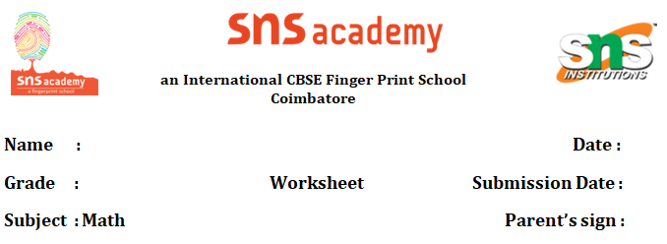

**Grade 7 Fractions and Decimals Question Bank**

1. Converting Fractions to Decimals

- Convert 3/4 to a decimal.

- Express 5/8 as a decimal.

- Change 7/20 to a decimal.

2. Converting Decimals to Fractions

- Write 0.75 as a fraction in simplest form.

- Convert 0.625 to a fraction.

- Express 0.4 as a fraction in lowest terms.

3. Comparing Fractions and Decimals

- Which is greater: 2/5 or 0.45?

- Compare 3/8 and 0.375.

- Order from least to greatest: 0.6, 2/3, 0.65, 3/5.

4. Adding and Subtracting Fractions

- Solve: 1/3 + 2/5.

- Calculate: 7/8 - 1/4.

- Find the sum of 5/6 and 3/4.

5. Adding and Subtracting Decimals

- Compute: 4.56 + 2.39.

- Solve: 7.8 - 3.25.

- Calculate: 12.04 + 0.96.

6. Multiplying Fractions

- Find the product: 2/3 × 5/7.

- Multiply: 1/4 × 8/9.

- Solve: 3/5 × 2/3.

7. Multiplying Decimals

- Calculate: 0.4 × 0.7.

- Find: 2.5 × 1.3.

- Solve: 0.06 × 4.2.

8. Dividing Fractions

- Divide: 3/4 ÷ 1/2.

- Solve: 5/6 ÷ 2/3.

- Calculate: 7/8 ÷ 1/4.

9. Dividing Decimals

- Compute: 4.8 ÷ 0.6.

- Solve: 9.6 ÷ 3.2.

- Find: 0.75 ÷ 0.25.

10. Word Problems

- A recipe needs 2/3 cup of sugar. If you make 1/2 of the recipe, how much sugar is needed?

- A tank holds 3.5 liters of water. If 0.7 liters are used, how much water remains?

- A rope is 5/6 meters long. If it is cut into 1/3-meter pieces, how many pieces are there?

11. Mixed Operations

- Solve: (1/2 + 3/4) × 0.5.

- Calculate: 2.4 + 1/3 - 0.8.

- Find: (2/5 × 0.6) ÷ 1/3.

12. Simplifying Fractions

- Simplify: 12/18.

- Reduce: 24/36 to lowest terms.

- Write 15/25 in simplest form.